Lab 3: Simulate an ALU
(2+2 hours)

Goal
To learn how to write Verilog testbench to simulate the ALU designed in Lab 3.

Procedure
Simulate the ALU with the following functions.
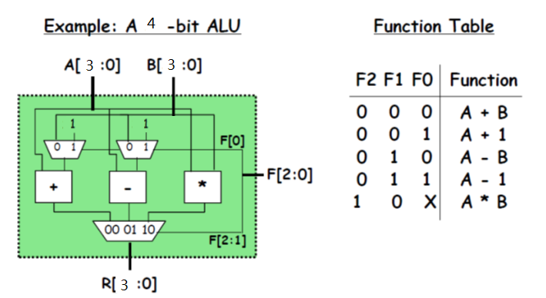
- Simulate the 3-1 mux module by writing a 3-1 mux testbench, then check whether the output is right.
- Simulate the subtract module by writing a subtract testbench, then check whether the output is right.
- Simulate the ALU module by writing an ALU testbench, then check whether all the function is worked.

